CSE 7008 Analysis Report

Mert Bayraktar

202151075008

**1. Introduction**

This analysis report focuses on the application of Model-Driven Engineering (MDE) in the field of indoor localization. Indoor localization, the process of determining the position of objects or individuals within indoor environments, presents unique challenges compared to outdoor localization systems like GPS. MDE offers a structured and systematic approach to address these challenges by utilizing modeling techniques and simulation tools to design and develop efficient indoor localization systems. This report analyzes the benefits, limitations, and key considerations of applying MDE in the context of indoor localization.

**2. Benefits of Model-Driven Engineering in Indoor Localization**

**2.1. Systematic Development Process**

MDE provides a systematic and disciplined approach to designing indoor localization systems. By employing modeling languages and tools, developers can create abstract representations of the system, capturing its structure, behavior, and relationships. This enables a clear understanding of the system's requirements, facilitating efficient development and reducing errors.

**2.2. Simulations for Validation**

MDE allows for the creation of simulation models that can accurately represent complex indoor environments. Simulations enable developers to assess the performance of the indoor localization system under various conditions, such as different signal strengths, interference levels, or user mobility patterns. This validation process helps refine the system design and optimize its performance.

**2.3. Scalability and Adaptability**

MDE techniques enable the creation of scalable and adaptable indoor localization systems. Through abstraction and modular design, MDE allows for the seamless integration of new technologies, sensors, or algorithms into the system. This flexibility ensures that the system can evolve over time and accommodate future advancements in indoor localization technologies.

**2.4. Collaborative Development**

MDE promotes collaboration among multidisciplinary teams involved in the development of indoor localization systems. By providing a shared modeling language and a common understanding of the system, MDE facilitates effective communication and coordination among stakeholders, including software engineers, domain experts, and end-users.

**3. Challenges in Indoor Localization with MDE**

**3.1. Complex Indoor Environments**

Indoor environments pose challenges for modeling and simulation due to their intricate layouts, including walls, partitions, and various obstacles. Modeling these environments accurately requires detailed information about the physical structure, which can be time-consuming and challenging to obtain. Additionally, incorporating environmental factors such as signal propagation characteristics, multipath effects, and interference sources into the models adds complexity to the design process.

**3.2. Heterogeneous Sensor Integration**

Indoor localization often relies on integrating data from multiple sensors, such as Wi-Fi, Bluetooth, magnetic field sensors, or inertial sensors. However, sensor heterogeneity brings challenges in terms of data fusion, synchronization, calibration, and ensuring compatibility among different sensor technologies. Designing and implementing effective sensor fusion algorithms that can handle variations in sensor accuracy, reliability, and sampling rates is a complex task within the MDE framework.

**3.3. Signal Interference and Quality**

Indoor environments are characterized by significant signal interference from various sources, including other wireless devices, physical structures, and environmental factors. The presence of multipath propagation and non-line-of-sight conditions further degrades signal quality and accuracy. Addressing these challenges within the MDE approach requires sophisticated modeling of signal behavior, interference sources, and developing robust algorithms to mitigate the impact of interference on localization accuracy.

**3.4. Real-World Variability and Calibration**

Simulating indoor environments in MDE models often involves simplifications and assumptions, which may not fully capture the real-world variability encountered in actual indoor spaces. Calibration of the simulation models with real-world measurements becomes crucial to ensure accurate and reliable results. However, obtaining precise calibration data for diverse indoor environments and different sensor configurations can be challenging, potentially impacting the accuracy of the MDE-based indoor localization system.

**3.5. Scalability and Computational Efficiency**

Scalability is a critical factor in designing indoor localization systems that can handle large-scale deployments, multiple users, and real-time positioning. MDE-based approaches should consider the computational efficiency of the simulation models, as well as the scalability of algorithms and data processing techniques. Efficient data management, optimization of simulation runtime, and scalability of the developed system are challenges that need to be addressed within the MDE framework.

**4. Dataset Description**

This section described the dataset, supporting software, and the data collection phase.

**4.1. Fingerprinting Dataset**

The dataset is provided as ‘csv’ files to facilitate data processing, and no specific software is needed to read the ‘csv’ files. The ‘csv’ file consists of the following columns:

1. **Coordinates**: Three columns in the dataset shows the GPS coordinates (latitude, longitude, and floor) of the classrooms where the measurements were taken. Example: (x, y, z) = (36.89672737982672, 30.649524638866378, 1) for a measurement in the dataset.
2. **RSSI and Mac Address**: There are 85 columns named as all MAC addresses seen during the total measurement time. These columns are sorted in numerical and alphabetical order. In each row, the RSSI information taken from the Wi-Fi AP with that MAC address is shown in the dataset. Each row corresponds to one measurement. The non-heard Aps are set to 0 dBm. For instance, in the dataset, Wi-Fi AP with MAC address ‘04:bd:88:84:ac:a0’ was heard at -66 dBm. The RSSI values are interpolated between the timestamps of each measurement. It is important to mention how these RSSI values are distributed in the database. Figure 1 introduces the histogram and KDE of all MAC addresses in the database.

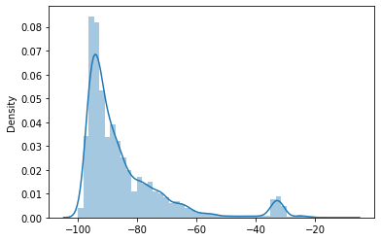

Figure 1. Dataset Kernel Density Function and Histogram of all mac addresses in the database.

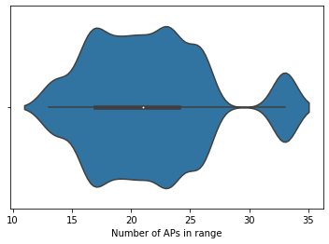

Figure 2. Violin Plot of average reachable access points in one measurement.

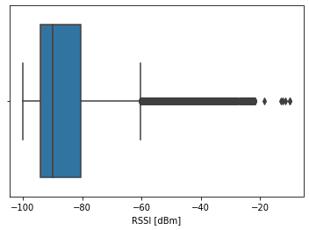

Figure 3. Boxplot of RSSI measurements.

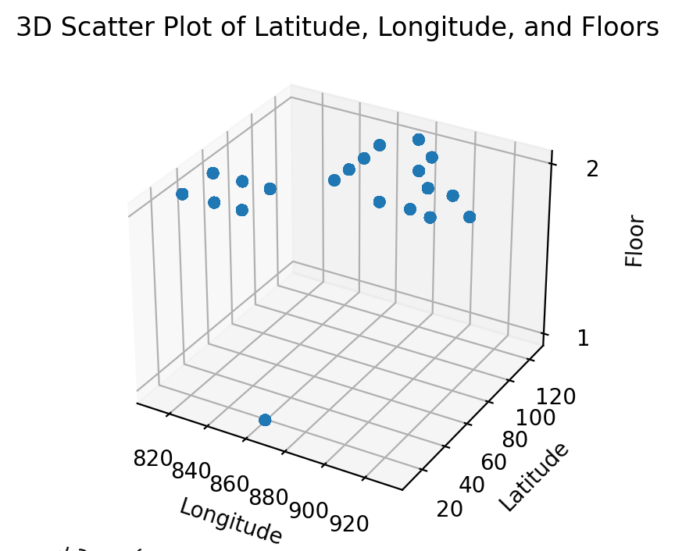

Figure 4. 3D Scatter plot of measurement points’ coordinates.

1. **Timestamp**: The timestamp column represents interpolated timestamps of each measurement in UNIX time format. The timestamps provided are recorded in a mobile device between starting and ending times of each measurement.
2. **Room**: The room column represents the room’s identification number where the measurements were done. Data collection was done in the Engineering Faculty Building’s classrooms, and these room identification numbers are set before measurements were taken in the mobile application. There are a total number of 20 classrooms in the dataset.

**4.2. Data Collection Procedure**

The data were collected with an Android application coded in Flutter. The server has been written using C#. The model of the phone used for data collection is Samsung Galaxy J200F with Android version Android 7.1.2. In order to obtain maximum efficiency in the data collection process, the device charge was kept at maximum with power bank. Measurements were taken in all classrooms of the Engineering Faculty Building for a one-minute duration. Since the exact location of the access points in the building is not known and some of them are mobile access points of the people in the building, as a result of one-minute measurements, less than 15 Wi-Fi devices were filtered and the final result obtained was 85 Wi-Fi Access Points. Measurements were not taken in line-of-sight since fingerprinting does not require line-of-sight. In the mobile application used, the faculty is selected first. Thereafter, if there is more than one building in the faculty, the building selection is made and the floor selection can be made on the screen that opens afterward. The floor plan of the building is loaded from the database according to the selected floor. A point is selected on the plotted areas on the map to start the measurement. Room ID, room type, and category are displayed in the window that opens at the top. Pressing the yellow arrow button in this window starts a one-minute measurement. The measurements are recorded in the database. Mobile application screenshots can be found in appendix section.

**5. Conclusion**

Solving the problem of indoor localization using Model-Driven Engineering presents several challenges. By understanding and addressing these challenges, such as complex indoor environments, sensor integration, signal interference, calibration, and scalability, MDE-based solutions can be designed to overcome these obstacles. Advanced modeling techniques, fusion algorithms, signal processing approaches, and scalable design considerations will play crucial roles in developing efficient and accurate indoor localization systems within the MDE framework.

**6. Appendix**

